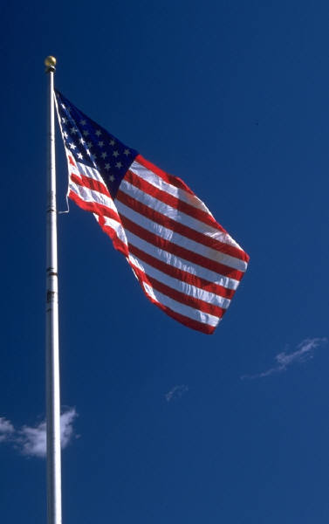



Missing In America Project

*Public Invitation for Veteran Interment Service:*

We respectfully invite all Veterans, Veteran Organizations and Patriotic Individuals, to be part of the Interment, with Honors, for the unclaimed cremains of a fellow Veteran. His remains will be escorted to his final resting place and honored with a Military Service.

All vehicles and motorcycles are also invited to participate in the escort to Florence National Cemetery.

For more information contact Larry Truax at 843 855-7050 or [truaxlw@gmail.com](mailto:truaxlw@gmail.com)

For up to date information about any time changes please check on Facebook:

Missing In America Project – South Carolina

Or

www.miap.us

***Date and Location:***

***Friday,***

***4 March2022***

***1400 hrs***

***at***

***Florence National Cemetery***

***803 E. National Cemetery Road***

***Florence,, SC 29506***

The Dignified Transfer to Florence National Cemetery

will depart from Speedway

2949 Highway 501

Aynor, South Carolina

on 4 March at 1300 hrs

Please stage at the Speedway at 1230 hrs and ride brief at 1245 hrs

**You are also welcome to meet at the cemetery. Please be at the cemetery at 1400 hrs**

**Local Law Enforcement Agencies will be assisting the escort.**

***“You Are Not Forgotten”***